Name:R.Mouni Course:Generative AI
Reg:no:192472283 Code:CSA6502

Lab 1: Product Description (Zero-shot, One-shot, Few-shot)
Zero-Shot:
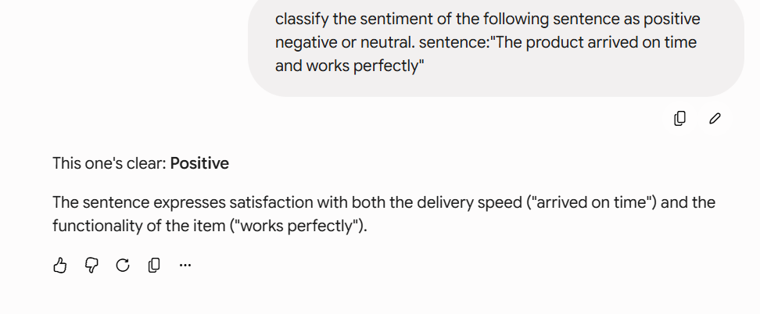
One-Shot:
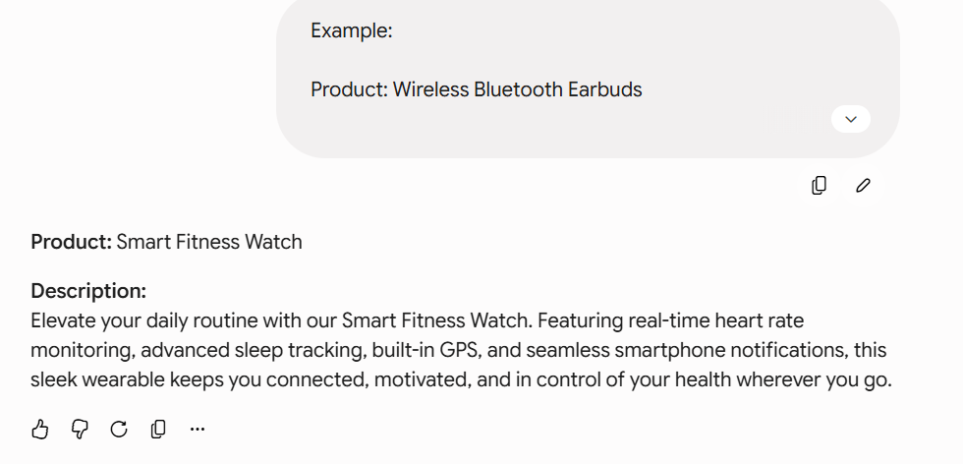

Few-Shot:
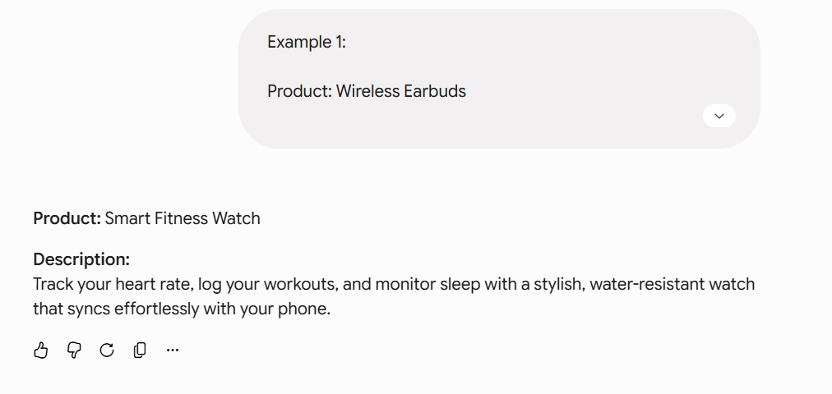

Lab 2: AI Healthcare Blog
Zero Shot:
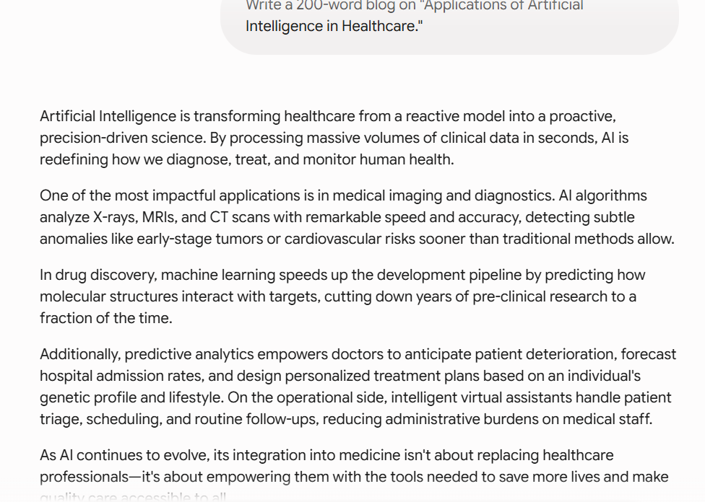

One shot:
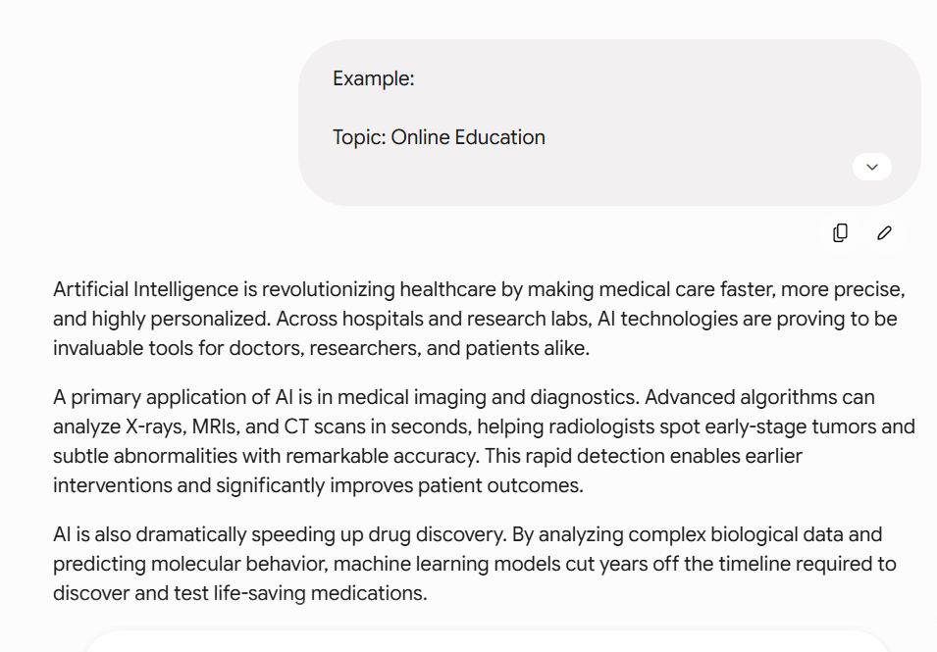
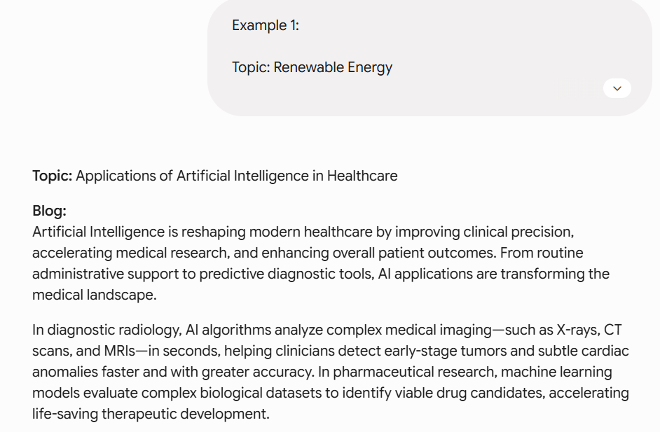
Few-Shot:
Lab 3: Article Summarization
Zero-Shot:
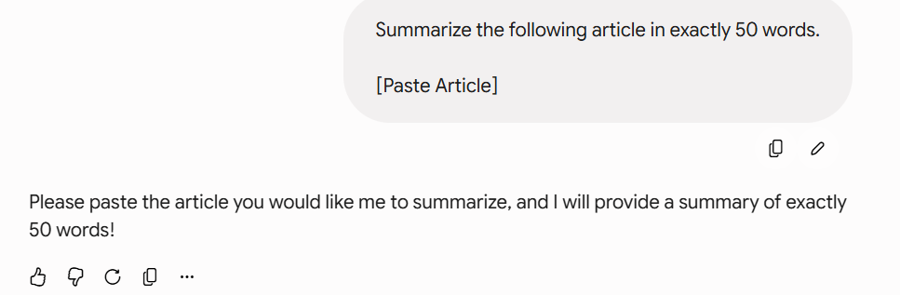

One-Shot:
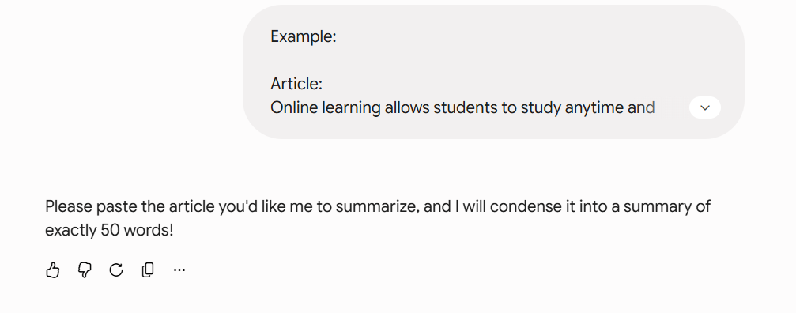
Few-Shot:
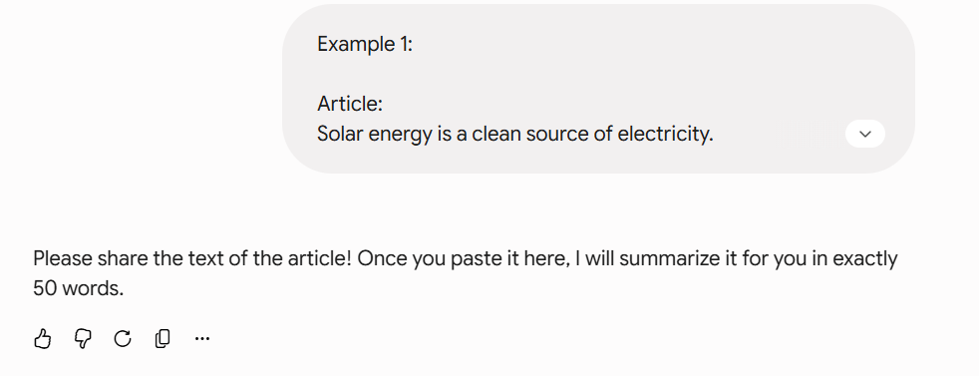

Lab 4: Professional Leave Email
Zero-Shot:
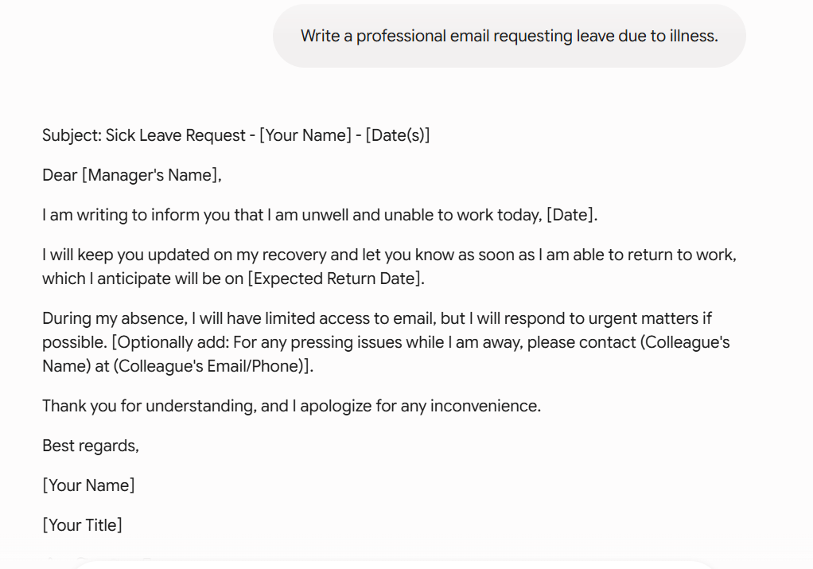

One-Shot:
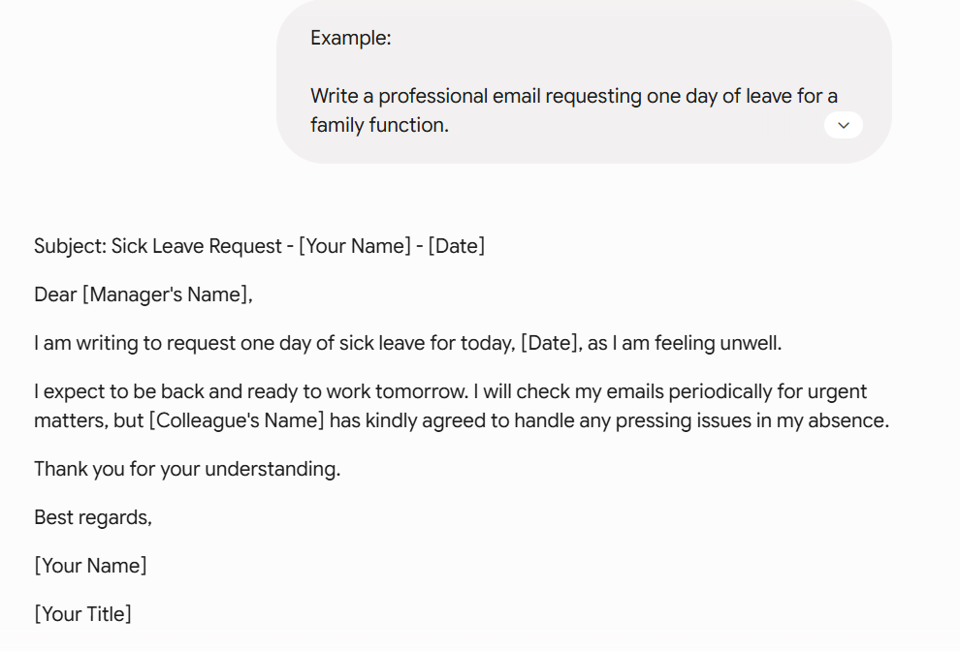

Few-Shot:
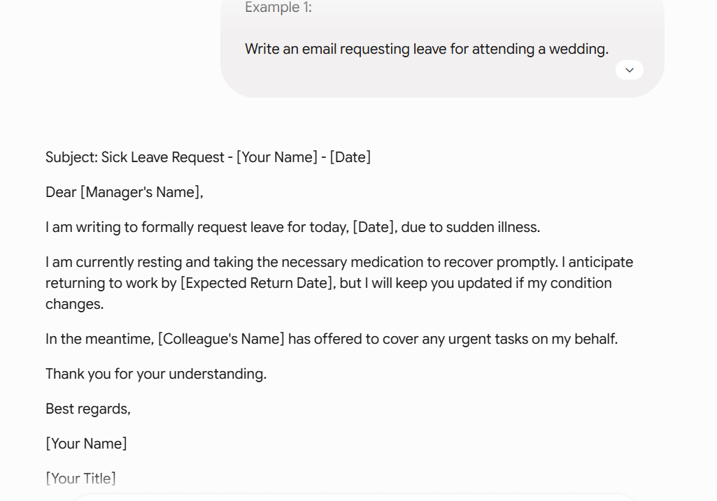

Lab 5: AI Workshop Social Media Post
Zero-Shot:


One-Shot:


Few-Shot:


